|  |  |
| --- | --- |
|  | **San Francisco State University** |
|  | **CSC 648 - 848** |
|  | **Milestone 0 Submission Form** |
|  | **Section 04 Team 03** |
|  |  |
| **Item** | **Credentials** |
|  |  |
| **Website URL** | <http://52.53.156.79:8080/> |
|  |  |
| **SSH URL** | [52.53.156.79:22/](http://52.53.156.79:8080/) |
|  |  |
| **SSH Username** | ubuntu |
|  |  |
| **SSH Password/** |  |
| **Key** | No password, key attached |
|  |  |
| **Database URL** | (relative to server) localhost:3306 |
| ( |  |
| **Database** | root |
| **Username** |  |
|  |  |
| **Database** |  |
| **Password** | !K5-,w'(ZvT5Uy=3 |
|  |  |

!10

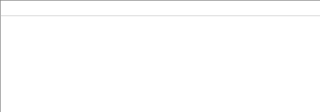

Addition information, anything to help with executing or grading of the current milestone

To run locally, run npm start from src/application folder

